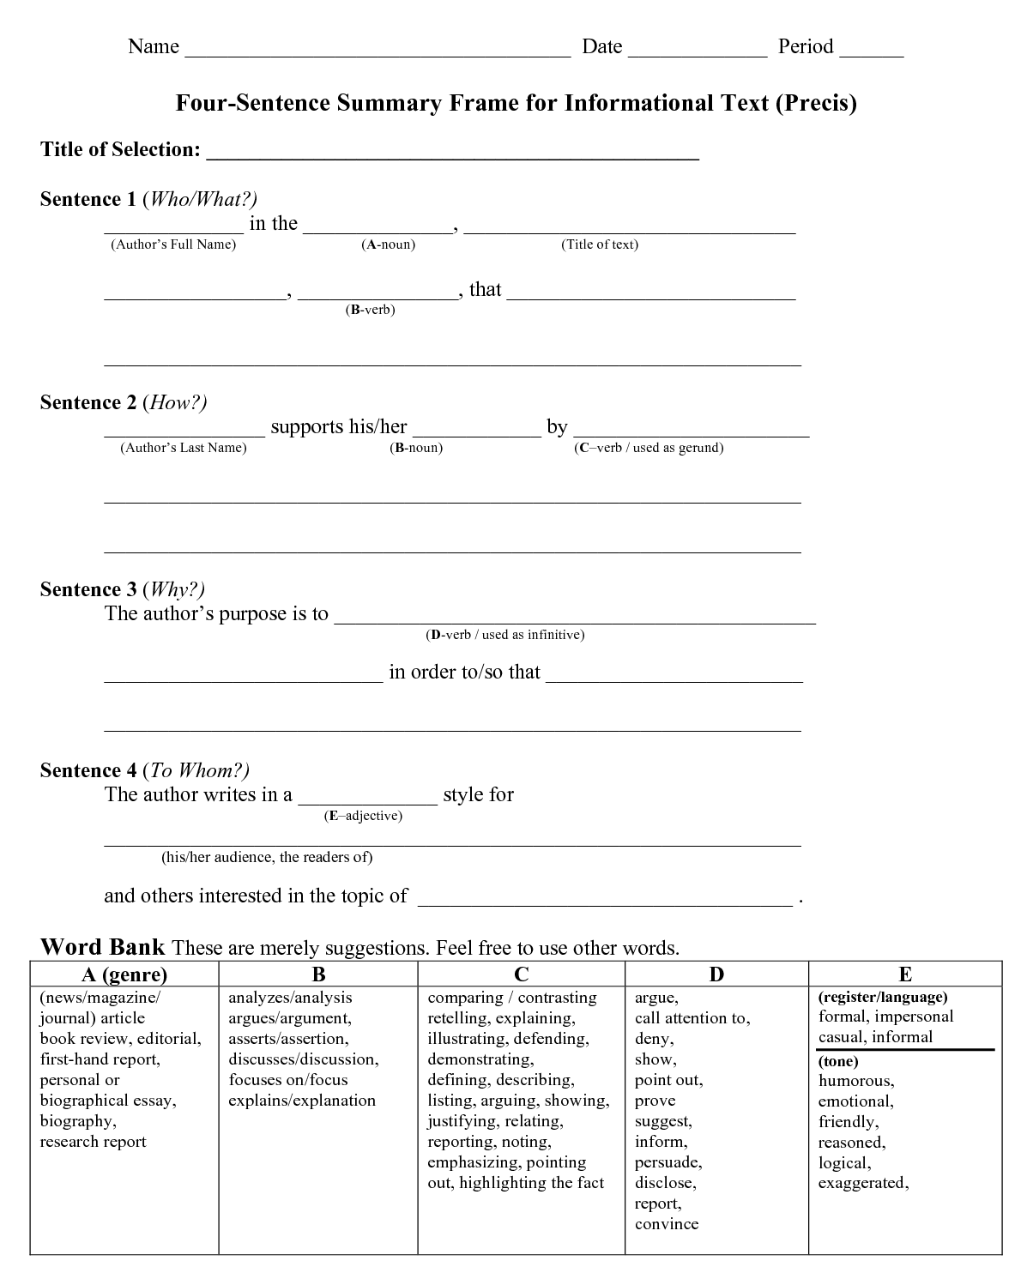
Taken from: http://www.lanzbom.org/
Jones 1
Bob Jones
Professor Kridner
English 10 Period 4A
11 September 2011
Rhetorical Précis
In the article “End Homework Now” (2001), Etta Kralovec and John Buell claim that the practice of assigning homework is not an effective teaching method because its negative effects outweigh its benefits. Kralovec and Buell support their claims by providing examples of how homework disrupts families, overburdens children and limits learning and by dispelling myths about the benefits of homework and providing alternative practices that would lead to improvement in student achievement. The authors’ purpose is to make the reader question a practice that is a trademark of the U.S. education system and decide whether it is conducive to creating a “smarter” student. They seem to be speaking to the entire educational community: administrators, teachers, students and parents.

